Volunteer role profile 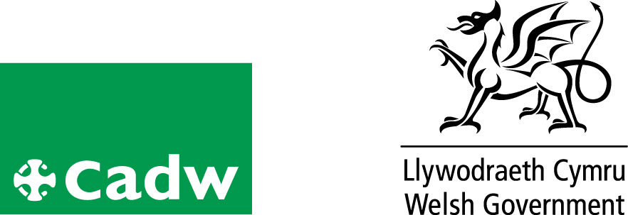
Volunteer Object Handling Sessions

Location | Plas Mawr
Volunteer Manager
Role Description | - To provide a warm and friendly welcome to all our visitors  - To actively engage with visitors using objects from the Tudor Treasure Chest  - To respond accordingly to the various needs and interests of the different visitors.  - To help us deliver excellent customer service  - To be part of the public face of Cadw
Qualifications/ Special Skills | No formal qualifications required
Days | Any day Monday – Sunday inclusive
Time | Hours are any time between 9-5 (although we would expect a minimum of 3hours per fortnight)
Essential |  | Desirable
Good Communication skills |  | Welsh Speaker
Ability to work both within a team and alone |  | Friendly and approachable
Reliable, responsible and punctual. |  | Interest in history, primarily the Tudor/Stuart periods
Probation period |  | 3 Months
Volunteer Benefits |  | • Training  • Experience of working in Heritage  • Meet new people with similar interests  •Become part of a team
Training |  | Full training will be given
Expenses |  | Reasonable cost of travel between home and place of volunteering will be paid. Other reasonable expenses must be agreed in advance
This is a voluntary role, binding in honour only and is not legally binding
Contact:
Tel:01492580167/573605
e-mail:plasmawr@wales.gsi.gov.uk

