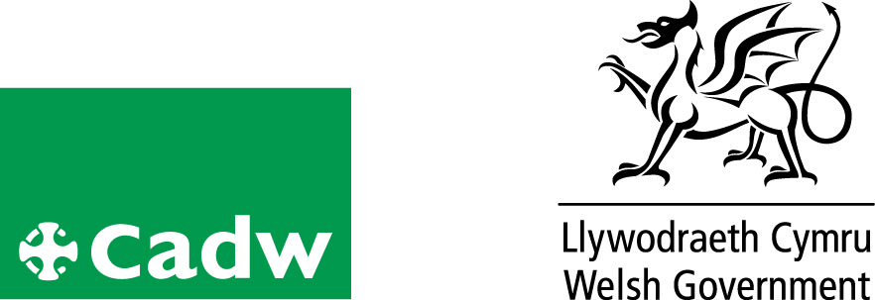
Volunteer role profile

Education Activities Assistant
Location | Plas Mawr
Volunteer Manager
Role Description | - To work with teachers to deliver the self-led activities  - To set out and tidy away the resources for activities  - To assist the team at Plas Mawr in evaluating the effectiveness of each educational activity  - To supervise the movement of schools around the site to ensure good health and safety practice
Qualifications/ Special Skills | No formal qualifications required
Days | Weekdays during term time
Time | As and when required
Essential |  | Desirable
Good Communication skills  Enthusiasm to learn and develop and to help others learn and develop |  | Welsh Speaker
Ability to work both within a team and alone
Friendly and approachable
Reliable, responsible punctual |  | Experience of working with children and young adults.
Probation period |  | A minimum of 6 sessions
Volunteer Benefits |  | • Training  • Experience of working in Heritage  • Meet new people with similar interests  •Become part of a team
Training |  | Full training will be given
Expenses |  | Reasonable cost of travel between home and place of volunteering will be paid. Other reasonable expenses must be agreed in advance
This is a voluntary role, binding in honour only and is not legally binding
Contact
Tel:01492580167/573605
e-mail:plasmawr@wales.gsi.gov.uk

